+

**School Nurse**

Educating to truth, goodness and beauty.

Terling Road, Dagenham

RM8 1JT

Headteacher Ms Clare Cantle

Email: office@allsaintsschool.co.uk

Tel: 020 8270 4242

Fax: 020 8595 4024

JOB

OPPORTUNITY

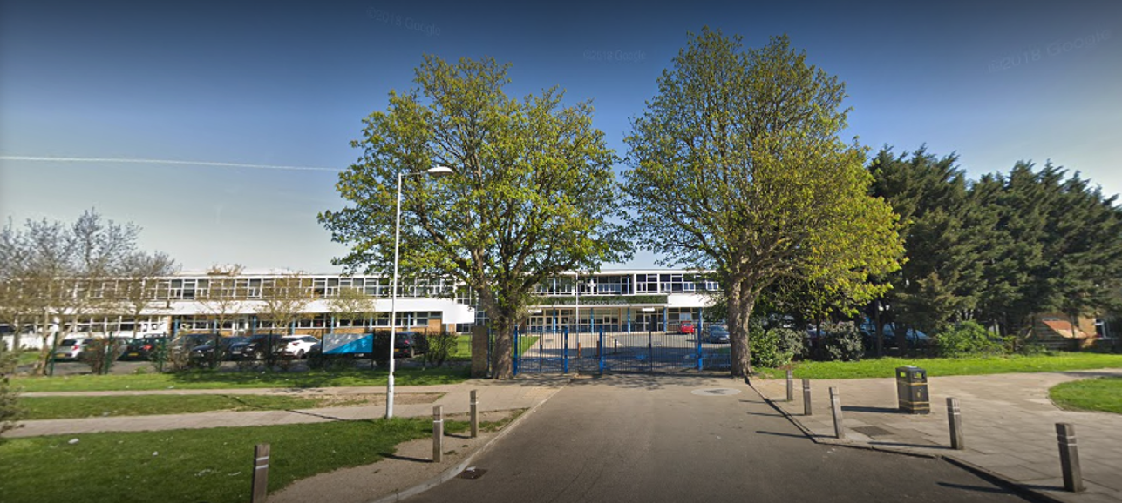

**School Mission Statement**

We are all one in Christ, our mission and our responsibility is to recognise all individuals in our community as part of the body of Christ and to value them accordingly in our treatment of them, thriving and progressing in a spirit of togetherness.

(1 Cor. 12-29)

|  |  |
| --- | --- |
| Role | **School Nurse** |
| Closing Date for Application | Wednesday 31st July |
| Required For | September 2024 |
| Term | Permanent – Fixed term one year in the first instance. |
| Salary | Scale 5 |

**All applicants must complete a CES application form for the post.**

**School Information**

All Saints Catholic School is an Outstanding Catholic comprehensive school situated in the London Borough of Barking and Dagenham and within the Diocese of Brentwood, with good transport links to central London.

All Saints Catholic School has over 1400 students from year 7 to 13.  The school achieves excellent exam results, with a Progress 8 score of 0.45 (well above average).  We have received an Educational Outcomes award for being in the top 12 percent of schools in the country for progress.

Our core values of Respect, Understanding, Affection and Humour underpin all aspects of our pastoral and academic daily routines.  Our 2024 Ofsted judged us to be an Outstanding school, highlighting that “the school successfully encourages pupils to demonstrate its core values, which include respect and understanding others. In addition to this, pupils meet the school’s exceedingly high academic expectations and achieve very well”.

  We have won a number of awards which reflect our inclusive approach to education, including being awarded the Rights Respecting Schools Gold Award and the Inclusion Quality Mark, this is indicative of our “One in Christ” motto that we apply every day to everyone that is a part of the school community.

Our learning is based on the transcendental values of truth, goodness and beauty. We encourage pupils to discover truth, develop a sense of goodness and appreciate beauty in the world around them.

Please watch our school videos available at: <http://allsaintsschool.co.uk/> to get a further insight into life at All Saints.

**Job Purpose:**

To provide a clinically effective, high quality and professional nursing service to the School community, including emergency and in-patient assessment, treatment and care to pupils, and emergency and first aid care to anyone either working at or visiting the School.

**Main duties/responsibilities**

Promoting the Health, Safety and Wellbeing of Pupils and Staff

At all times the School Nurse will:

* Maintain awareness of, and comply with the School’s Health & Safety policy.
* Where appropriate, conduct and document risk assessments in his/her area of responsibility
* Work closely with other members of staff to facilitate excellent pastoral care, including close liaison with Heads of School and School Counsellor.
* Stay on top of Public Health matters and liaise with the School Executive
* Liaise with members of staff who are identified as clinically (extremely) vulnerable to Covid-19 and produce an individual risk assessment.
* Run INSET as appropriate and as agreed with the Deputy Head Pastoral.

**Key Responsibilities:**

* Day to day responsibility for running the medical centre and the services provided for all pupils, staff and visitors.
* Planning, organising and monitoring the provision of health care across the School
* Support of first aiders to ensure adequate levels of care are provided
* Writing policies, procedures, individual pupil care plans and welfare plans and ensuring these are kept up to date
* Ensuring his/her own nursing practices comply with the professional Code of Conduct
* Ensure they revalidate every three years and remain on the NMC register with a valid PIN number
* Participating in relevant CPD to ensure that treatment, advice and information are current, evidence based and in line with current legislation
* Keeping up to date with health promotion initiatives
* Ensuring children follow a safe return to normal activity following concussion
* Keeping a register of pupil specific medical needs and maintaining school medical records.
* Administer medicines as necessary.
* Maintain sufficient levels of medical supplies and drugs.
* Managing the security and control of drugs and medicines, maintaining a clear audit trail.
* Provide pupils and staff with first aid in emergencies and as a result of an accident or incident on the premises.
* Communicate with parents as and when appropriate.
* With Head of HR manage and implement a rolling programme of first aid training to ensure staff have first aid skills as appropriate to their role.
* Manage childhood immunisations as required.
* Maintain such records and statistics as are required.
* Gather appropriate medical information and maintain necessary records and statistics. Passing these to the Bursar for review at Governors meetings.
* Work alongside the catering and pastoral teams as appropriate.
* Complete all relevant forms following accidents.
* Deal with bodily fluids in accordance with School policy.
* Maintain professional competence by attending courses and keeping knowledge up to date on areas such as chronic diseases and childhood ailments.
* Provide teaching staff with pupil based medical information prior to school trips and outings.
* Ensure the maintenance of all first aid kits on site and in School vehicles, checking these on a termly basis.
* Ensure that the School’s medical protocol is adhered to at all times.
* Attend meetings as required by the Principal, Vice-Principal, Bursar, Deputy Head Pastoral and Heads of School.
* In liaison with the Deputy Head Pastoral and Heads of School participate in PSHE lessons on subjects such as puberty, sexual Health, breast examination and leading a healthy lifestyle.
* Implement the provisions of the School’s Child Protection policy.
* Attend school open days, outings and events as required, eg. School bonfire night.
* Undertake any other professional duties which fall within his/her capabilities and which may be reasonably requested or required by the Executive
* Ensuring confidentiality and integrity at all times, on all school matters

Persson specification

|  |  |
| --- | --- |
| **Qualifications** |  |
| Registered Nurse | Essential |
| First Aid at work certificate or Paediatric First Aid 12 hour course | Desirable |
| Evidence of commitment to continuous professional development | Essential |
| **Experience and Knowledge** |  |
| Previous experience of school nursing | Desirable |
| Previous experience of working with children | Essential |
| Knowledge of safeguarding issues | Essential |
| Knowledge and awareness of children’s health issues | Essential |
| **Skills and competences** |  |
| Empathy and understanding of the emotional needs of children | Essential |
| Assertiveness in promoting and advocating the health and wellbeing needs of pupils | Essential |
| Ability to communicate both verbally and in writing, clearly and effectively | Essential |
| Highly practical with common sense and initiative | Essential |
| Highly organised | Essential |
| Ability to prioritise and manage changing workloads and situations and work under pressure | Essential |
| Good IT skills | Essential |
| Ability to work on own initiative and as part of a team | Essential |